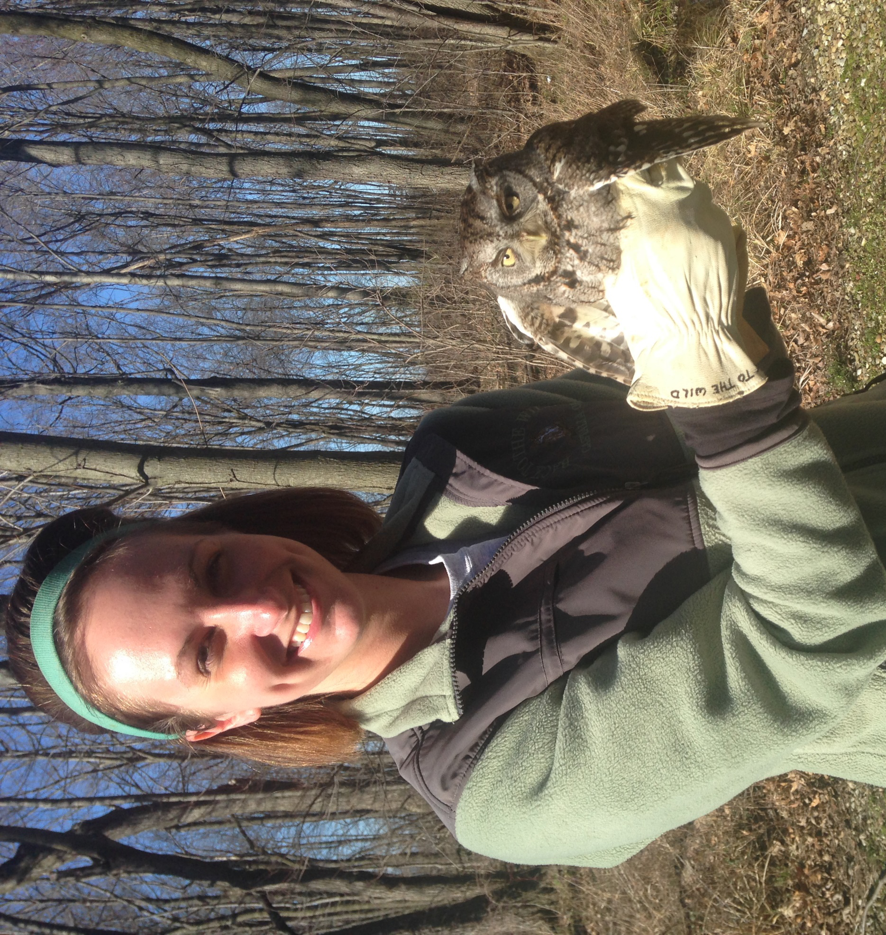

Frequently Asked Questions about Volunteering at Back to the Wild

- What will my duties include?
  - One of the first things to keep in mind before you volunteer at any wildlife rehabilitation center is that you will not be handling animals (at least not in the beginning). Being a volunteer at an organization that houses wildlife means a lot of hard work and a lot of cleaning.
  - Our volunteers are instrumental in helping us keep cages clean, floors swept and mopped, dishes done, and generally making Back to the Wild a good habitat for the animals as well as a great place for our visitors to explore. Taking care of 200 animals is not glamorous. It requires close contact with big (and sometimes very gross) messes.
- When do I get to handle animals?
  - Not all of our volunteers get to handle animals.
  - It is easy to forget that these are wild animals. None of them particularly enjoy being held or pet and doing so can lead to injuries to yourself or to the animal.
  - After a volunteer has exhibited responsibility, reliability, and awareness of the nature of the animals in our care, we might begin training on feeding babies and working with some of the other animals.
  - Handling an animal or going in a cage that you have not been given express permission to handle or enter by the staff supervisor (Sammie Villa) or the manager (Heather Tuttle) will result in termination of your volunteer position. We cannot stress enough the danger of working with wildlife. Proper training and safety measures are required.
- What if I already have experience handling wildlife?
  - In that case, we will can start training you to handle the animals we work with here.
  - Before we start the training, you will need to provide reference letters and phone numbers of the center you handled animals for as well as a list of all of the species you handled.
- What kind of hours do I have to work?
  - We are VERY flexible with the schedule. We can work around your job, school, and other life activities. You can work as many or as few hours as you would like.
  - While we are flexible, we do rely on our volunteers to be here when they are scheduled. If you cannot, we ask that you give us a call to let us know. It is no problem if you can’t make it as long as you let us know ahead of time.
- What do I get out of this experience?
  - Well, experience! Your volunteer hours can be recorded and saved to use for college applications and more.
  - Our volunteers mean a lot to us. While it may seem they get stuck with a lot of cleaning, without them, we wouldn’t be able to keep up. As such, we like to reward them with the opportunity to join in on animal releases, examinations, programs, and more.
  - You get to help Back to the Wild make a difference! Whether you’re cleaning a cage or helping with tours, you are a cog in the Back to the Wild machine and without you, we couldn’t keep up with all of our many patients and residents. Every job helps us help wildlife no matter how silly it may seem.
- What do I do to become a volunteer?
  - You can call us at 419-684-9539 (ask for Sammie Villa or Heather Tuttle) or email us at volunteers@backtothewild.org with any questions or concerns you have.
  - All volunteers must fill out a volunteer application and return it to Back to the wild. If we have a position open, we will call you for an interview. Keep in mind that due to the volume of applications we get, we don’t always have an immediate position open or enough positions for everyone.
Thank you so much for your interest in the volunteer program at Back to the Wild! We hope to hear from you soon.

